CMPT-416N – Cybersecurity

Andrew Tokash
Section 111 : Thursdays 2:00-4:45 Hancock 0006
Syllabus updated – January 2, 2022

Faculty Availability

Office Hours: Hancock 3002
“Going to office hours is one of the pieces of advice that is most often given, but rarely taken.”
- Ellen Anderson

- I have office hours at least three days each week. Walk-ins welcome, but preference given to scheduled appointments. To see the current schedule: calendly.com/atokash
- I prefer ILearn messages (rather than email) for communications, as it keeps all of a course’s materials and communications in one place. If you do email me, please include the course and section number.
- Please use ILearn forum/discussion for general questions on material, expectations, etc. and for posting interesting topics for class discussion

Introduction
This course is required for Cybersecurity major/minor degrees and provides the foundation for further studies. It’s an excellent course for other CompSci students as you’ll learn the basics of protecting software and hardware. And it’s an important course for non-CompSci majors also; knowing cybersecurity is a skill almost all employers value.

It’s also beneficial for your personal life: How do you know if a wifi network is secure? What should you do if you get an ‘expired digital certificate’ message? How do you know if an e-mail is real or spoofed? How can you protect your data and yourself in the digital world?

NOTE: Students are expected to spend at least two hours of outside time for each one hour of class time! This is a 4-credit course; students are expected to work on labs during non-class time.

I provide a weekly “Read Me First” file that will list meeting times, videos to view, due dates, and other information.

Catalog Course Description

This course provides an introduction and overview of key concepts in cybersecurity for cloud and enterprise data centers. We provide a framework for understanding cybersecurity concepts based on the NIST cybersecurity lifecycle. Students will be introduced to core concepts including physical data center security, authentication, access control, identity management, secure software development principles and practice, cryptography, cloud security, compliance, and governance. Students will be introduced to a variety of common security attacks, including code injection, man-in-the-middle, phishing, buffer overflows, and adjacency attacks. Using a self-contained lab environment, isolated from the campus network and the Internet, students will be able to practice common hacks and defense strategies, and learn how to scan websites and cloud environments for security vulnerabilities. Practical examples of real-world security breaches will be used as case studies to illustrate key concepts.

Prerequisites

- I expect college level work. All submissions and presentations should be proofed and professional. Submissions should be properly formatted.
- CMPT-306 and 307 – We’ll cover some of what you learned in Data Communications and Internetworking, but reviewing and refreshing that material would be a bonus.
- Number Systems – You needed to know binary and hex and ASCII for both Data Communications and Internetworking. You’re going to need that again. If you are not 100% comfortable with these, there are many online tools to help you.
Educational Approach / Philosophy of Education

I hope to provide a challenging learning experience that build foundational knowledge and provide students with ‘deep learning’. This will be a collaborative endeavor, and requires self-learning students who care about the material. A truly successful course is not just about getting a grade; it should change, enhance or transform your life (L. Dee Fink).

“The value of a college education is not the learning of many facts but the training
of the mind to think." - Thomas Edison

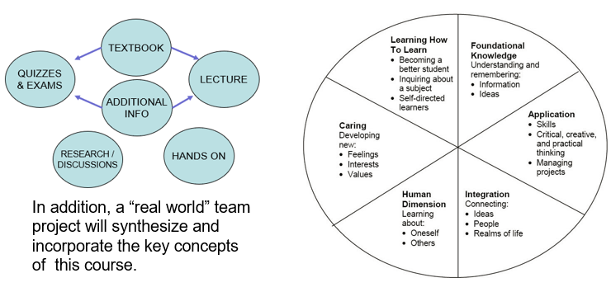

Required Text and Resources
- Elementary Information Security by Richard E. Smith (3nd edition, 2019, Jones & Bartlett).
- The course uses a required online cloud-based lab environment. Ensure you get the premier access offering from the publisher (do NOT order the advantage access, which does NOT include the labs).
  - ISBN for print book and premier/lab access : 9781284214741
  - ISBN for ebook and premier/lab access : 9781284320930
- NOTE: you do not need to specify a course id when you access the J&B software.
- To increase the effectiveness of our classroom time, I expect students to read the chapters prior to our time together, which will be better spent reviewing and clarifying the material, and augmenting the textbook with additional material and activities. (This will also help you become self-learners, an important skill for your future careers.)
- Additional course materials may be provided in class by the instructor. Materials used in connection with this course may be subject to copyright protections
- Non-textbook material will also be presented on lecture slides. I strongly advise students to take notes!
- Please refer to my website for links to articles, videos, and other resources
https://aptokash.github.io/Home/
- I also strongly recommend the following book and websites:
  - “Cybersecurity Blue Team Toolkit” by Nadean Tanner
  - The “Center for Internet Security” website
  - ThreatPost Today daily bulletins

Labs – Team Activities

New labs will be assigned almost weekly, with students also working in teams. The labs will be based on the bundled software. Each team must create a PPT lab report/presentation. While there will be one lab report for each team, each person must submit the (same) report in iLearn for grading. For each lab one or two teams will be asked to present to the class, with each team member presenting a portion of the presentation.

Refer to the “Lab Software Access” file in our resources for more details.

Note: To ensure labs are graded properly, each slide needs the author noted on the bottom.

Computer Science Department Goals
“Today, companies expect not only technical hard skills, but also so-called professional skills [which] include communication, project management, conflict management, diversity management and teamwork.” – Marc-Oliver Pahl

- Prepare students for employment in a technology field or for graduate study in a technology field.
- Provide students with both theoretical knowledge and skills-based proficiencies in the five core technology competencies: programming, hardware, data communications, data management, and systems/software analysis and design.
- Provide students with fundamental knowledge of business administration and management so that graduates will be able to work effectively within businesses and other organizations.
- Develop interpersonal skills for working effectively on teams.
- Develop effective written and oral communication skills.

Course Objectives

- Understand computer security, white- and black-hat hacking, Google hacking, vulnerabilities, etc. [1,2]
- Understand computer and file access controls and demonstrate how to set controls on the Windows operating system. [1,2]
- Understand both symmetric and asymmetric encryption techniques. [1,2]
- Understand computer networking, including both the security implications and business management controls. [1,2,3]
- Understand the operation and security requirements for computer applications and the Internet. [1,2,3]
- Understand cybersecurity’s legal requirements and the ethical dimensions. [3]
- Perform simulated computer sessions using state-of-the art security tools. [1,2,3]
- Research a real-world security breach; develop and present a comprehensive security report. [1,2,3,4,5]
- Work in teams on lab assignments and class presentations. [1,2,3,4,5]
- Submit professional module and lab assignments. [5]

A detailed list of ‘core competencies’ is listed in the iLearn resources (file “Class Notes”). This list details, by module, expected acquired knowledge topics and demonstratable skills.

I hope students will: master the material and its relationship to other courses; understand the personal and social aspects of the subject; and desire to learn MORE about cybersecurity.

Note: Due to the pandemic we’re often forced to incorporate online instruction and online team-work. While this has some drawbacks, it also prepares students for the modern workforce, which more and more include remote employees and online team projects.

Coursework Submission Guidelines

Assignment, lab and project files must be submitted into ILearn. Documents must follow a standard naming convention and have proper page headers. Refer to the file “Submission Guidelines” in the Ilearn Resources section.

Note: For group/team work, all members must submit in ILearn!

The guidelines file also lists information on using/citing references and the difference between a 90% A and a 100% A.

Course Evaluation

Students are assessed through exams, self-assessment quizzes, assignments, presentations and projects. Written projects and presentations will be used to assess their interpersonal, written and oral skills.

15% Bi-weekly team lab assignments
15% Weekly self-assessment quizzes on textbook chapters
40% Exams (midterm and final)
20% Weekly assignments, in class quizzes, etc.
5% Comprehensive team case study
5% Class Attendance & Participation

The aggregate grading policy for midterm and final grades will be the standard Marist grading system, and will be displayed in the iLearn gradebook.

All assignments are to be submitted by the due date specified. Make-up opportunities for assignments, assessments, and exams are provided only for verifiable extenuating circumstances cleared through CAAS. Acceptable excuses for late submission of assignments include situations covered in the Student-Athlete Handbook, illness, and serious extenuating circumstances (e.g., death in the family, serious illness).

NOTE: I generally do not provide extra-credit or make-up assignments.

The aggregate grading policy for midterm and final grades will be the Marist grading system, and will be displayed in the iLearn gradebook. Please continuously monitor your iLearn grade and contact me for any questions. Do not wait until final weeks to bring up any issues.

 | 95 A | 90 A-
87 B+ | 83 B | 80 B-
77 C+ | 73 C | 70 C-
65 D+ | 60 D

Class Attendance Policy

Students are expected to attend all classes and to actively participate in classroom activities and discussions. Cell phones/laptops/tablets may only be used for note taking and doing labs. I expect all students to be respectful.

Important Notes

I normally teach this course in two periods per week, but this semester was set up as an extended period that meets only once per week. Thus, missing one class this semester will miss a full week of material. Please make every effort to attend all classes. Ensure that you have a study partner to provide class notes in the event of any absences.

In the event of a campus wide ‘pause’, we will be forced to hold classes remote. If that happens, students are expected to Zoom in and keep their video feeds live, and will be responsible for any class work covered during the normal class time. Also, in the event of inclement weather, we will hold classes remote!

Tentative Semester Schedule

Below is the tentative semester schedule, and will change through the semester. The updated schedule is maintained in the course READ ME FIRST file, and displayed at the start of each class.
 |  | Chapters
1/20 | Course Introduction; Introduction to Cybersecurity | -
 | Security from the Ground Up | 1
1/27 | Ethics (Ch 1) , Vulnerability, Reconnaissance, Computers | 2
2/3 | Controlling Files, Sharing Files | 3,4
2/10 | Storing Files, | 5
2/17 | Authenticating People, SCADA, Industrial Hacks | 6
2/24 | Encrypting Files | 7
3/3 | Secret And Public Keys | 8
3/10 | Mideterm Exam + Emily Harris Visit
3/17 | Spring Break
3/24 | Encrypting Volumes | 9
3/31 | Connecting Computers, Networks of Networks | 10,11
4/7 | End to End Networking, Home PCs/BBS's, Perimeters, IDS/IPS | 12
4/14 | Network encryption | 13
4/21 | Internet Services & Email; Perimeters, IDS's/IDP's | 14
4/28 | The World Wide Web | 15
5/5 | Supplemental : IoT, Enterprises, Legal Issues, Privacy , Assessments | S
 | Case Study Presentations/ Final Review
 | Final Exam Week of 5/9-5/13

The “Read Me First” File

As mentioned above, Ilearn will have a READ ME FIRST file with to-do’s and schedule, team breakdown, core competencies, and other information.

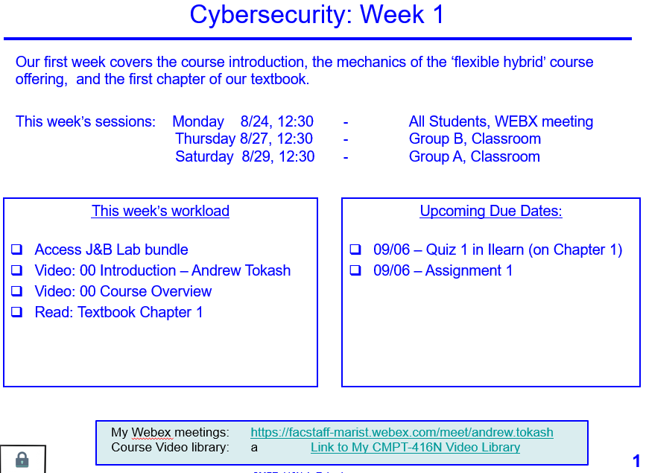 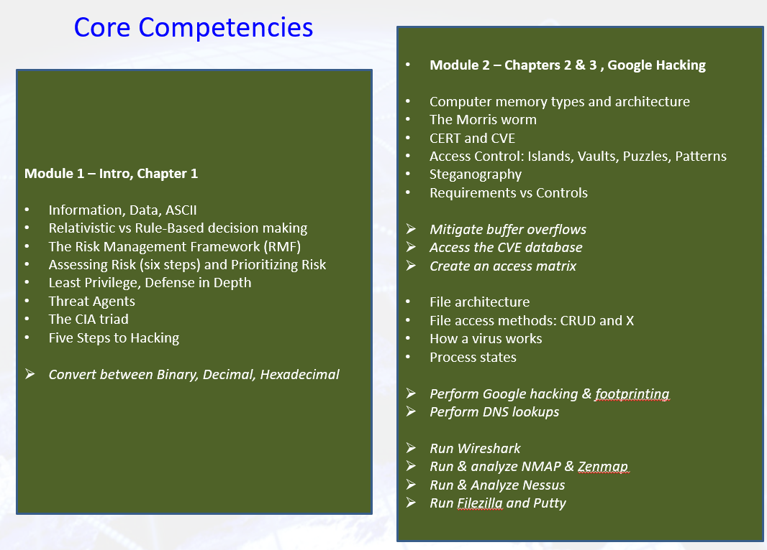
Learning Disabilities

Students have all types of learning disabilities. It is your responsibility to notify the professor in the beginning of the semester in order to make sure you are successful within this course! If you’re unsure whether you have a learning disability, make sure you see Special Services within Donnelly as soon as you suspect your disability!

Academic Honesty

Faculty will uphold and enforce the general policies of this institution on academic honesty and plagiarism. All examinations, assignments, and projects are subject to the standards of academic honesty as described in the Student Handbook and/or other related publications.

Neither plagiarism not cheating will be tolerated. If you are suspected of cheating, you will be asked to explain the work. If you cannot you will be ejected from the course with a failing grade, in addition to any other forms of recourse available to the instructor as specified by the Student Handbook.

You are encouraged to discuss the course material, concepts, and lessons with other students in the class. However, your labs, exams and discussions must be your own work. If you are caught copying or otherwise submitting material that is not solely your work, you will fail the course and a letter will be sent to the department chair.

Please consult the ACM code of ethics. See www.acm.org/constitution/code.html.

Diversity and Inclusion

The college's academic mission is immeasurably enriched by students with diverse experiences. Our finest efforts as intellectual beings heavily rely on the exchange of ideas. Interactions in our classrooms among persons and groups with diverse backgrounds, ideologies, and experiences facilitate these efforts by allowing us all to be more reflective about the varied historical and social contexts in which we work and learn.

In this course, we will challenge each other’s thinking while working collaboratively to ensure that the classroom is a space of safety and bravery. Our classroom offers an environment where individuals of varying opinions, experiences, and backgrounds can freely learn without fear of being silenced.
Aspects of diversity include, but are not limited to, race, ethnicity, color, nationality, sex, gender, gender identity, gender expression, class, sexual orientation, religion, age, ability, and veteran status. Students who would like to be identified in a manner other than what is indicated on the course roster can contact me privately to indicate name, pronoun and any other preferences they may have.

How to Get an “A”

- Attend classes. If something is unclear ASK for a better/different explanation.
- Be an active student. Take notes, listen, speak, ask questions.
Refer to: https://post.edu/blog/preventing-information-overload-note-taking-tips-students/
- Do a quick review of chapters BEFORE the class to identify confusing sections.
- Read the chapter and review each section’s TEST YOUR UNDERSTANDING questions.
- Do all assignments and submit them on time with proper formatting and citations. Begin assignments early in case you have questions.
- Do not copy assignments from other students, the Internet or any other source.
- Take your time with SELF ASSESSMENTS. Review material BEFORE taking the quiz.
- Study for the exams. Use the Core Competencies as a study guide.
- Work with other students and take advantage of office hours.
- Monitor your grades weekly.
- Use a flashcard application (ex: Quizlet) to help you study. Use the publisher’s flashcards included with premier access.
- Participate fully in team projects!
- Use the Marist Writing Center and the other resources.
- If you have any questions, confusion or issue, address them immediately. Do not wait until the end of the semester to do so.

Changes to This Syllabus

01/02/2022 Original syllabus

End of Document

The reference number in brackets [ ] indicates the department goal that is being met with the fulfillment of the objective.

